AI Governance Tool — Solution Architecture
Nov 2, 2026 · @Gladwin
ISC challenge: AI decision-making process visibility, traceability and compliance governance (SSC sponsor). HustleBench Advisory Services Inc. Draft for internal review before implementation. Companion to the solution outline.

1. Architecture summary, scope and principles
The solution is an event-driven governance platform. It keeps a versioned library of governance requirements and a registry of AI systems linked in a traceability graph. When either side changes, it runs the least reassessment that keeps findings trustworthy, and it routes every result to a named human reviewer. It runs on-premises on Red Hat OpenShift in a Protected B environment, with an in-tenant language model, and is built and delivered solely by HustleBench on open-source components and open standards.
Scope of this architecture: the TRL 5 prototype covering all 18 mandatory outcomes, all 4 additional outcomes and the derived requirements in section 2. It does not cover production operations, formal authorisation to operate, or full ISO/IEC 42001 and EU AI Act content packs.
Architecture principles:
ID | Principle | What it means for the design
P-01 | Humans decide | AI drafts and flags; no finding, control or requirement version is final without an authorised approval
P-02 | Deterministic where it matters | Applicability, impact and response tier come from versioned rules, so the same input always gives the same answer
P-03 | Open by default | Governance data in OSCAL and JSON Schema; interfaces in OpenAPI and CloudEvents; open-source components only in the core
P-04 | Integrate, don't replace | Departmental inventories, ML platforms and monitoring tools stay the system of record; the platform governs their output
P-05 | Traceable end to end | Every finding links to clause, control version, evidence, submitter, reviewer and decision
P-06 | Sovereign and secure | All data, the model and all processing stay inside the GC-controlled Protected B environment
P-07 | Tenant-owned configuration | Thresholds, profiles, retention, residency and reviewers are configuration owned by each department, not code
P-08 | Bilingual and accessible from the start | EN/FR and WCAG 2.1 AA are built into every screen, report and message
P-09 | Least change, most assurance | Change triggers targeted reassessment; unaffected findings carry forward with their approvals
These principles align with the GC Digital Standards and the GC Enterprise Architecture Framework, which the department's architecture review board will apply.

2. Requirements register
Each challenge clause carries an ID used throughout this document; M = essential (mandatory), A = additional (desired), D = derived from HustleBench decisions and GC obligations.
ID | Requirement (abridged from the challenge notice)
M-01 | Continuously align registered AI systems with Canadian regulations, policies, directives and other requirements; identify affected systems; indicate when reassessment is required
M-02 | Interoperate with enterprise systems, AI/ML platforms and governance solutions, integrating with minimal customization
M-03 | Exchange governance information through standards-based APIs, connectors and data exchange: system metadata, ownership, intent, deployment status, funding state, client information, objectives, risk assessments, AIA, control requirements (playbooks), findings, audit evidence, monitoring results, approvals, decision records
M-04 | Collect, aggregate and maintain governance information across multiple systems
M-05 | Use open standards and documented interfaces to reduce dependency on proprietary technology
M-06 | Restrict, monitor and control administrative, support and data access in line with GC requirements
M-07 | Let organisations define and manage data residency, retention, access and deletion without vendor intervention
M-08 | Assess and reassess systems when requirements or assessment frameworks are added, modified, replaced or retired; translate requirements into traceable controls; assess control satisfaction; identify non-conformities
M-09 | Let authorised users add, modify, version, replace or retire requirements and frameworks for individual systems or groups; demonstrate the Policy on Service and Digital, DADM, AIA, AI Strategy and AI ethics guidance
M-10 | Manage controls and assessment criteria the same way; apply different criteria by intended use, risk profile or governance need; show extensibility to NIST, ISO and the EU AI Act
M-11 | Generate human-readable explanations: applicable requirement, evidence considered, result, confidence or certainty measure
M-12 | Collect, link and retain assurance artefacts (control mapping, assessment records, evidence references, approvals, exceptions, attestations, remediation actions, audit histories) and identify whether each was provided by an authorised individual
M-13 | Produce measurable results distinguishing Met, Partially met, Not met, Not applicable and Unable to determine
M-14 | Let authorised reviewers validate, reject, modify or annotate findings, with a retained audit history
M-15 | Assess and reassess risks from data, models and AI-generated outputs and feed them into governance assessments
M-16 | Assess data risks and quality, with baselines, thresholds and a traceable record of issues
M-17 | Define, evaluate and reassess configurable risk, performance and quality measures per system
M-18 | Evaluate and monitor AI outputs for accuracy, quality, fairness, consistency, safety and alignment with operational requirements
A-01 | Deploy on-premises, in private cloud and in Canadian-hosted cloud without significant architectural change
A-02 | Provide bilingual UI, documentation, reporting and governance workflows
A-03 | Support multiple organisations on a shared platform with independent policies, controls, reporting and oversight
A-04 | Generate reports, alerts and notifications; integrate with collaboration, communication and ticketing systems
D-01 | Demonstrate TRL 5 in a Protected B environment
D-02 | Keep all AI-drafted content subject to human approval
D-03 | Meet WCAG 2.1 AA (GC Standard on Web Accessibility)
D-04 | Register and assess the platform itself against its own GC content pack
D-05 | Keep the language model and all data in-tenant, with no external calls
D-06 | Deliver solely by HustleBench, using open-source components and standards
D-07 | Support legal and access-to-information holds on records
D-08 | Visibility into decision-making: decision maps, decision records and output traceability for registered systems

3. Business architecture
The platform serves eight roles across two levels: an enterprise level that owns shared governance content, and a tenant (department) level that applies it.
Actors and roles:
Role | Level | Responsibilities
Platform administrator | Enterprise | Operates the platform, onboards tenants; no access to tenant governance content by default
Governance author | Enterprise or tenant | Loads and changes governance sources; approves AI-drafted obligations and controls
Tenant administrator | Tenant | Sets residency, retention, holds, thresholds, profiles, reviewers and role assignments
AI system owner | Tenant | Registers systems, supplies evidence, owns remediation actions
Evidence contributor | Tenant | Submits artefacts and attestations for assigned controls
Reviewer | Tenant | Validates, rejects, modifies or annotates findings; approves remediation
Approver (executive) | Tenant | Accepts residual risk, signs exceptions and attestations at the delegated level
Auditor | Enterprise or tenant | Read-only access to findings, evidence and audit history; exports
Business capabilities:
Capability | Sub-capabilities | Requirements
Governance content management | Source intake, obligation decomposition, control authoring, versioning, profiles, crosswalks | M-08, M-09, M-10
AI system inventory | Registration, synchronisation, reconciliation, AIA import, decision mapping | M-03, M-04, D-08
Impact and change management | Change detection, impact analysis, response tiering | M-01, M-08
Compliance assessment | Applicability, control evaluation, five-state results, explanations, confidence | M-08, M-11, M-13
Assurance and evidence | Evidence intake, provenance, attestations, exceptions, audit history | M-12, M-14
Risk and performance monitoring | Measure definition, baselines, thresholds, breach handling | M-15 to M-18
Oversight and response | Review, approval, remediation recommendation, ticketing | M-14, A-04
Reporting and communication | Dashboards, reports, alerts, exports | A-04, A-02
Platform and tenant administration | Tenancy, roles, residency, retention, holds | M-06, M-07, A-03, D-07
Core business processes (runtime detail in section 7):
- BP-01 Onboard a system — register or synchronise, import AIA, assign profile, run baseline assessment.
- BP-02 Process a governance change — intake, AI-assisted decomposition, author approval, publish version, impact analysis, reassessment.
- BP-03 Process a system change — detect change, re-evaluate applicability, reassess.
- BP-04 Handle a measure breach — evaluate threshold, update linked findings, alert, reassess.
- BP-05 Review findings — validate, reject, modify or annotate; finalise.
- BP-06 Respond — draft remediation, approve, raise ticket, close with evidence, reassess.
- BP-07 Audit — trace and export findings, evidence and decisions.

4. Information architecture
Governance data is held in twelve core entities, each versioned, tenant-scoped, bilingual where it carries text, and mapped to an OSCAL model wherever one exists so it can be exchanged without translation.
Entity | Key attributes | OSCAL model | Classification | Retention driver
Governance source | Instrument, issuer, effective date, clause references, EN/FR text | Catalog (back-matter resource) | Unclassified | Life of instrument + tenant policy
Obligation | Atomic statement, source clause, applicability conditions, version | Catalog control part | Unclassified | Superseded versions kept
Control | Testable statement, method, expected evidence, version | Catalog control | Unclassified | Superseded versions kept
Playbook (profile) | Controls selected for a system group, parameters | Profile | Unclassified | Versioned
Crosswalk | Mapping between controls of two frameworks | Control mapping model where the OSCAL release in use supports it; otherwise profile annotations | Unclassified | Versioned
AI system | Owner, intent, objectives, client, funding state, deployment status, AIA level, decision type, agentic attributes | Component definition / System security plan (extended) | Up to Protected B | Tenant policy
AIA record | Imported questionnaire answers and impact level | Back-matter resource | Up to Protected B | Tenant policy
Measure | Definition, baseline, threshold, owner, linked control | Assessment plan (extended) | Up to Protected B | Tenant policy
Evidence | Artefact or reference, submitter, role, timestamp, SHA-256 hash, expiry | Assessment results (observation) | Up to Protected B | Tenant policy; holds override
Decision record | System, model version, inputs reference, output, explanation, human action | Not in OSCAL; OpenTelemetry span with links | Up to Protected B | Sampled; tenant policy
Finding | Control, version, state, rationale, confidence components, reviewer decision | Assessment results (finding) | Up to Protected B | Tenant policy; holds override
Action | Remediation, exception or attestation; owner; ticket reference | Plan of action and milestones | Up to Protected B | Tenant policy
Traceability graph: the entities above are nodes; edges record derived-from (obligation → clause), implements (control → obligation), applies-to (profile → system), evidences (evidence → control), assesses (finding → control version and system) and resolves (action → finding). Impact analysis is a traversal of this graph from the changed node.
Data lifecycle: create → version → supersede → retain → delete. Nothing is overwritten. Deletion follows the tenant's retention schedule, is blocked by any active legal or access-to-information hold (D-07), and is itself logged.
Data stores: relational and graph data in PostgreSQL with the Apache AGE extension; artefacts in S3-compatible object storage; audit records in an append-only, hash-chained log; full-text and bilingual search in OpenSearch. Everything is encrypted at rest with per-tenant keys.

5. Application architecture
Twenty-one components in six layers; the five reasoning components (C-07 to C-11) are HustleBench's core IP; every other component is an open-source building block, or a thin HustleBench service built on one.
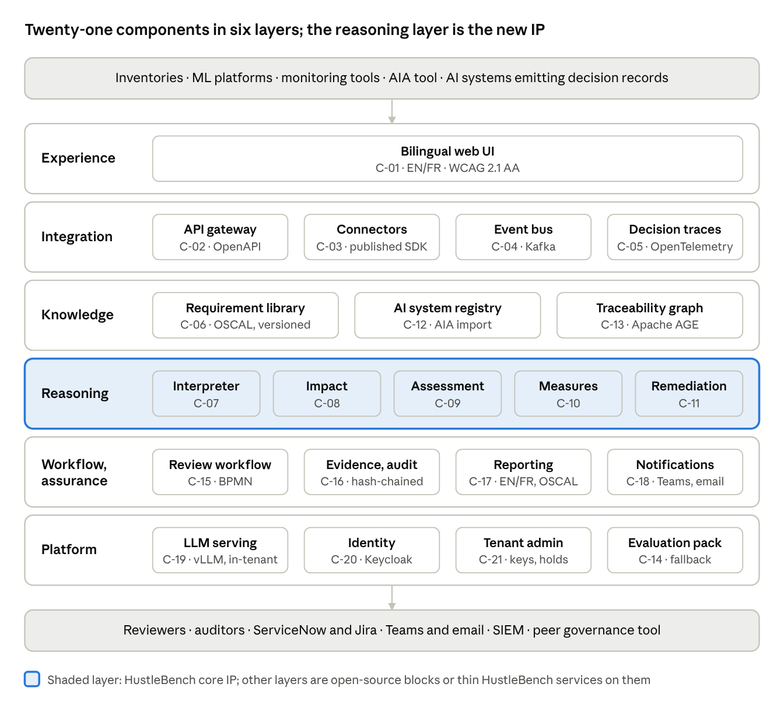
component view · 21 components, 6 layers
Governance information enters at the top through documented interfaces and leaves at the bottom as findings, tickets, alerts and exports; the IDs match the catalogue below.
ID | Component | Layer | Responsibility | Build basis | Requirements
C-01 | Bilingual web UI | Experience | All user journeys, EN/FR, WCAG 2.1 AA | React with i18n framework | A-02, D-03
C-02 | API gateway | Integration | Single entry for APIs; authentication, rate limiting, tenant routing | Open-source gateway on OpenShift | M-02, M-03, M-05
C-03 | Connector framework and SDK | Integration | Pull and push connectors; published SDK for new ones | HustleBench framework on open-source runtime | M-02, M-04
C-04 | Event bus | Integration | Carries change events that start reassessment | Apache Kafka (Strimzi operator), CloudEvents | M-01
C-05 | Decision trace service | Integration | Ingests and links decision records; sampling | OpenTelemetry collector, HustleBench linker | D-08
C-06 | Requirement and control library | Knowledge | Sources, obligations, controls, playbooks, crosswalks; versioning | HustleBench service; OSCAL tooling (open-source libraries) | M-08, M-09, M-10
C-07 | Requirement interpreter | Reasoning | Drafts obligations and control mappings from new or changed sources, with citations | HustleBench; retrieval over sources; in-tenant LLM (C-19) | M-08, D-02
C-08 | Impact analyser | Reasoning | Traverses the graph from a change; sets response tier | HustleBench; rules over the graph | M-01, M-08
C-09 | Assessment engine | Reasoning | Applicability, control evaluation, five-state results, confidence, explanations | HustleBench; Open Policy Agent for rule checks; LLM evidence review (flagged) | M-08, M-11, M-13
C-10 | Measures evaluator | Reasoning | Baselines, thresholds, breach records; links to controls | HustleBench | M-15 to M-18
C-11 | Remediation recommender | Reasoning | Drafts remediation actions for unmet controls | HustleBench; in-tenant LLM | M-14, D-02
C-12 | AI system registry | Knowledge | System records, source attribution, reconciliation, AIA import | HustleBench service on PostgreSQL | M-03, M-04
C-13 | Traceability graph | Knowledge | Nodes and edges across all entities; impact queries | PostgreSQL with Apache AGE | M-01, M-12
C-14 | Packaged evaluation component | Reasoning support | Drift, fairness and LLM evaluation where a department has no tooling | Open-source libraries (Evidently, Fairlearn class), packaged | M-16, M-18
C-15 | Review and approval workflow | Workflow | Review tasks, approvals, exceptions, attestations, separation of duties | Open-source BPMN engine | M-14, D-02
C-16 | Evidence and audit store | Assurance | Artefacts, provenance, hash-chained audit log | S3-compatible object storage; append-only log; W3C PROV | M-12, M-14
C-17 | Reporting and export | Assurance | Dashboards, bilingual reports, OSCAL and bulk export | HustleBench; open-source reporting | A-04, M-05
C-18 | Notification service | Workflow | Alerts and review requests to Teams and email | HustleBench | A-04
C-19 | LLM serving | Platform | In-tenant model inference; no external calls | vLLM on GPU nodes, open-weight model | D-05
C-20 | Identity and access | Platform | Federation with departmental IdP; roles and attributes | Keycloak | M-06
C-21 | Tenant administration | Platform | Tenants, residency, retention, holds, keys, role assignment | HustleBench | M-07, A-03, D-07

6. Integration architecture
Fifteen documented interfaces carry all governance information in and out; each is versioned, described in OpenAPI 3.1 or AsyncAPI, secured with OAuth 2.0 client credentials or OIDC, and tenant-scoped.
ID | Interface | Direction | Protocol and format | Counterpart | Requirements
I-01 | Registry API | In / out | REST, JSON Schema | Departmental AI inventories, portfolio tools | M-03, M-04
I-02 | Evidence API | In | REST, multipart upload, SHA-256 | System owners, CI/CD pipelines | M-12
I-03 | Metrics ingestion API | In | REST, JSON | ML platforms, monitoring tools, C-14 | M-15 to M-18
I-04 | Decision record ingestion | In | OTLP (OpenTelemetry) | Registered AI systems, AI gateways | D-08
I-05 | Governance library API | In / out | REST, OSCAL JSON (catalog, profile) | Governance authors, peer tools | M-09, M-10
I-06 | Assessment results API | Out | REST, OSCAL assessment results and POA&M | Peer tools, auditors, departmental GRC | M-03, M-05
I-07 | Event subscriptions | In / out | CloudEvents over Kafka and webhooks | ML platforms (model registered), CI/CD, subscribers | M-01, M-02
I-08 | AIA import | In | JSON export of the GC open-source AIA tool | Departments' completed AIAs | M-03, M-09
I-09 | ServiceNow connector | Out / status in | ServiceNow REST Table API | SSC ServiceNow instance | A-04
I-10 | Jira connector | Out / status in | Jira REST API | Jira projects | A-04
I-11 | Notifications | Out | Microsoft Graph (Teams), SMTP | Teams channels, email | A-04
I-12 | Peer governance sync | In / out | REST plus OSCAL round-trip | ServiceNow AI Control Tower, IBM watsonx.governance, compliance-trestle | M-02
I-13 | Bulk export | Out | JSON, CSV, OSCAL, PDF | Tenant (exit and archive) | M-05, M-07
I-14 | Identity federation | In | OIDC, SAML 2.0 | SSC identity provider | M-06
I-15 | Audit and security log export | Out | Syslog / CEF, JSON | Departmental SIEM and SOC | M-06
Platform events (CloudEvents types): governance.requirement.published · governance.requirement.retired · governance.criteria.changed · system.registered · system.changed · measure.breached · evidence.expired · finding.proposed · finding.finalised · action.approved · action.closed. Every event carries tenant, subject ID, version and correlation ID, so a full chain can be traced from cause to closure.
Integration patterns: pull connectors on a schedule for systems without events; push (webhook or event) where the counterpart supports it; reconciliation keeps one registry record with source attribution per attribute and raises conflicts to the system owner. ServiceNow and Jira connectors write tickets only after reviewer approval and read status back to close the action.
Proposed peer governance targets for I-12:
Target | Why it fits | Integration approach | Status to confirm
ServiceNow AI Control Tower (primary) | SSC already runs ServiceNow; the product is ServiceNow's AI inventory and governance layer and now extends to AI running outside the Now Platform | ServiceNow REST APIs: sync system inventory and risk status both ways; reuses the I-09 connection | Whether SSC's instance is licensed for it
IBM watsonx.governance with OpenPages | Widely used AI and model risk governance suite; OpenPages runs on premises and exposes a REST API | OpenPages REST API V2 for use cases, risks and findings; OSCAL export where mapping allows | Access to a test instance
compliance-trestle (OSCAL Compass) | Open-source OSCAL SDK and toolchain; proves standards conformance with no licence | OSCAL file round-trip validated by trestle in the CI pipeline | None; bundled in the build
Recommendation: build the ServiceNow AI Control Tower sync if SSC holds the licence, otherwise watsonx.governance; run the trestle conformance round-trip in every case, since it costs nothing and gives evaluators an independent check of OSCAL fidelity.
Connector SDK: a published template, test harness and conformance suite let departments or third parties add connectors without HustleBench involvement (M-02).

7. Runtime views
Five runtime flows cover every trigger; each names the components and events involved so it can be built and tested as a unit.
RV-01 Governance requirement change (BP-02)
- A governance author uploads a new or amended source in EN and FR through C-01 or I-05.
- C-07 aligns the two language versions clause by clause, decomposes changed clauses into draft obligations, proposes control mappings and cites the source text for each.
- C-15 routes the drafts to the author, who accepts, edits or rejects each one.
- C-06 publishes a new version and emits governance.requirement.published (or .retired).
- C-08 traverses C-13 to find affected profiles, systems and findings pinned to the old version, and sets the response tier per system.
- C-09 re-runs only the affected controls; findings are emitted as finding.proposed.
- C-15 creates review tasks; C-18 notifies owners and reviewers.
RV-02 Assessment framework or criteria change — as RV-01, starting from governance.criteria.changed; C-08 selects findings assessed under the old criteria, and escalates to full reassessment if AIA impact levels can shift.
RV-03 System change (BP-03)
- A connector (C-03) or event (I-07) reports a change: model version, data source, intended use, decision type or agent autonomy; or a new AIA is imported (I-08).
- C-12 updates the record and emits system.changed.
- C-09 re-evaluates applicability; if the AIA impact level changed, C-08 sets full reassessment; otherwise targeted.
- Findings proceed to review as in RV-01 steps 6 and 7.
RV-04 Measure breach (BP-04)
- Metrics arrive through I-03 from a departmental tool or C-14.
- C-10 compares each value with its baseline and threshold; on breach it records an issue and emits measure.breached.
- C-09 re-evaluates the linked controls; the finding moves to Not met or Partially met, or to Unable to determine if data is missing.
- C-18 alerts the system owner; C-15 opens a review task.
RV-05 Review, remediation and closure (BP-05, BP-06)
- A reviewer validates, rejects, modifies or annotates the finding in C-15; the original, the change and the reason are written to C-16.
- For Not met or Partially met, C-11 drafts a remediation action: what to change, the evidence that would close it, and the owner.
- The reviewer accepts, edits or rejects the action; on acceptance C-15 emits action.approved and I-09 or I-10 opens a ServiceNow or Jira ticket.
- The owner uploads closure evidence (I-02); ticket status is read back; action.closed triggers targeted reassessment of that control.
Evidence expiry is a scheduled job that emits evidence.expired; the affected finding moves to Unable to determine and follows RV-05.

8. AI design inside the tool
The language model is used in exactly four places, always produces drafts or flagged findings, and never decides applicability, impact or a final result.
Use | Component | Input | Output | Guardrail
Requirement decomposition | C-07 | New or changed source clauses (EN and FR) | Draft obligations and control mappings with clause citations | Author approval before publish; citation required or draft rejected
Evidence review | C-09 | Evidence artefacts and the control's criteria | Proposed result, rationale, cited passages | Confidence capped; below floor → Unable to determine; reviewer required
Explanation drafting | C-09 | Structured finding data | EN and FR plain-language explanation | Generated from structured fields only; reviewer sees source fields alongside
Remediation drafting | C-11 | Unmet criteria, system context, past approved actions | Draft action, closure evidence, suggested owner | Reviewer acceptance required before any ticket
Model and serving: an open-weight model with strong English and French performance, served by vLLM on GPU nodes inside the OpenShift cluster (C-19). No prompt, document or output leaves the environment (D-05). The candidate model is selected in the first phase against an EN/FR test set of GC instruments; the serving layer is model-agnostic so the model can be replaced without changing other components.
Retrieval: source texts, controls and evidence are chunked and indexed per tenant; retrieval is filtered by tenant and classification before anything reaches the model, so one tenant's content can never inform another's output.
Quality assurance of the AI: a held-out answer key of requirement decompositions and assessed findings, prepared by HustleBench governance practitioners, is run on every model or prompt change. Precision, recall of obligations, citation accuracy and EN/FR consistency are tracked over time and reported.
Security of the AI: prompt templates are version-controlled; evidence content is treated as untrusted data and isolated from instructions to resist prompt injection; outputs are schema-validated before use.
Self-governance (D-04): the platform is registered as an AI system in its own registry, carries its own AIA, and is assessed against the GC content pack with findings visible to evaluators.

9. Security architecture
The platform is designed to a Protected B, medium integrity, medium availability profile using ITSG-33 controls, with identity-based access, separation of duties and a tamper-evident audit trail as the three load-bearing mechanisms.
Identity and access (C-20): users authenticate through SSC's identity provider (OIDC or SAML) with MFA; service accounts use OAuth 2.0 client credentials with short-lived tokens. Authorisation combines roles with attributes (tenant, system group, classification), enforced at the gateway and again in each service.
Role permissions (summary):
Action | Platform admin | Governance author | Tenant admin | System owner | Evidence contributor | Reviewer | Approver | Auditor
Publish requirement or control version | No | Yes | No | No | No | No | No | No
Configure thresholds, profiles, retention, holds | No | No | Yes | No | No | No | No | No
Register or update a system | No | No | Yes | Yes | No | No | No | No
Submit evidence or attestation | No | No | No | Yes | Yes | No | No | No
Finalise a finding | No | No | No | No | No | Yes | No | No
Accept an exception or residual risk | No | No | No | No | No | No | Yes | No
Read findings, evidence and audit history | No | Library only | Yes | Own systems | Assigned controls | Assigned scope | Yes | Yes (read-only)
Access tenant data for support | Time-bound, tenant-approved only | No | Approves | No | No | No | No | No
Separation of duties: the person who submitted evidence for a control cannot finalise its finding; the author of a remediation action cannot approve it; every artefact records submitter identity and role at the time of submission (M-12).
Privileged and support access (M-06): step-up authentication, just-in-time elevation with tenant approval and automatic expiry, session recording for privileged sessions, and support staff who are Canada-based and security-cleared to the level SSC requires.
Audit (C-16, I-15): every read of Protected B content, every change, approval and administrative action is written to an append-only log in which each record carries the hash of the previous one, so tampering is detectable; logs stream to the departmental SIEM.
Data protection: TLS 1.2 or higher in transit using CCCS-approved algorithms; AES-256 at rest with per-tenant keys held in an in-cluster secrets manager (OpenBao); no data, prompt or telemetry leaves the environment. A privacy impact assessment covers any personal information in decision records.
Network: the platform sits in a restricted zone; only the gateway is exposed to the operations zone used by departmental users and systems; egress is denied by default.
Assessment readiness (D-01): HustleBench produces the security assessment evidence (control mapping, design, test results) for SSC's security assessment and authorisation process; authorisation to operate remains with SSC.

10. Technology and deployment architecture
The reference deployment is a single Red Hat OpenShift Container Platform cluster in a GC data centre, in a Protected B restricted zone, with a GPU worker pool for the language model and OpenShift Data Foundation for block and S3-compatible object storage.
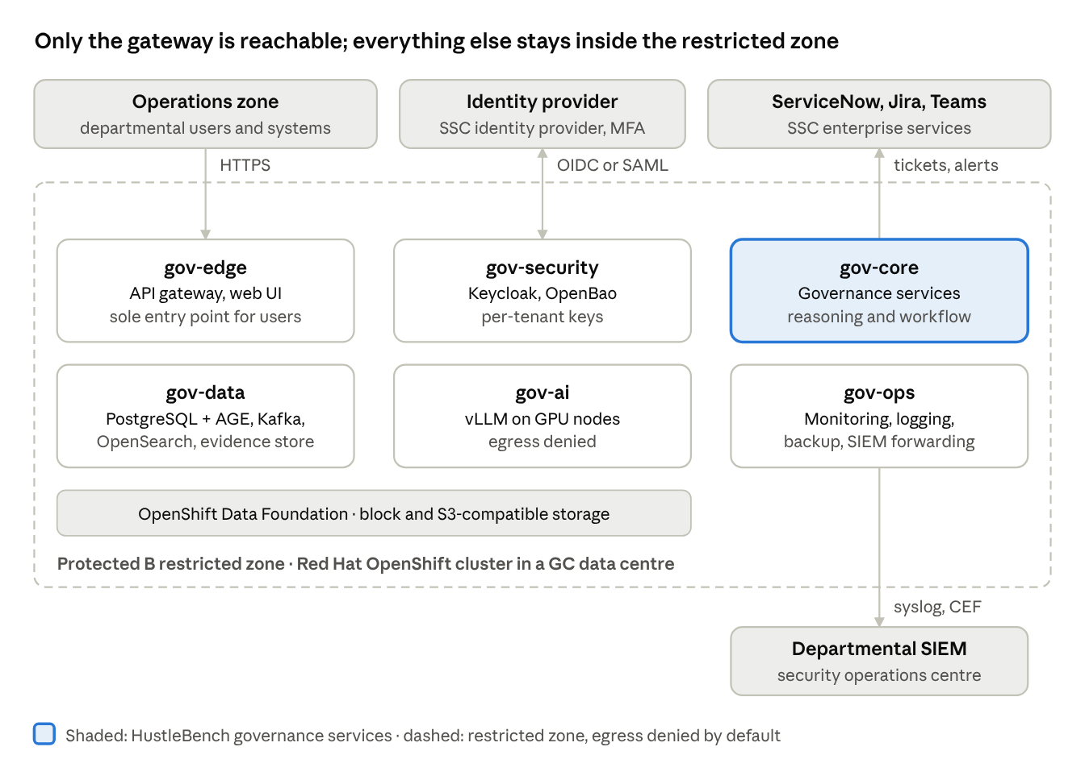
deployment view · 6 namespaces in one OpenShift cluster
Users and systems reach only gov-edge; identity is federated, tickets and alerts leave through gov-core connectors, and security logs stream to the departmental SIEM.
Namespace | Workloads | Notes
gov-edge | API gateway (C-02), web UI (C-01) | Only namespace reachable from the operations zone
gov-core | Library, registry, impact analyser, assessment engine, measures, workflow, recommender, reporting, notifications, tenant admin, connectors (C-03, C-05 to C-12, C-15, C-17, C-18, C-21) | Stateless services, horizontally scaled
gov-data | PostgreSQL with Apache AGE (operator-managed, HA), Kafka (Strimzi, 3 brokers), OpenSearch, traceability graph (C-13), evidence and audit store (C-16) on object storage | Persistent volumes on OpenShift Data Foundation
gov-ai | vLLM model serving (C-19), retrieval index, packaged evaluation component (C-14) | Scheduled to GPU nodes; egress denied
gov-security | Keycloak (C-20), OpenBao secrets and per-tenant keys | Restricted administrative access
gov-ops | Monitoring, logging, backup (OpenShift API for Data Protection), log forwarding to SIEM | Operated under the privileged-access model
tenant-<name> (optional) | Dedicated connectors or processing for a tenant needing stronger isolation | Default tenancy is logical within shared services
Resilience: the demonstration runs on a single OpenShift cluster. Stateful services run with replicas across the cluster's failure domains; PostgreSQL uses synchronous replication within the cluster and continuous write-ahead-log archiving; backups are written to object storage outside the cluster's own storage pool, so the platform can be rebuilt from backup if the cluster is lost. A second-site design is documented for production but not built at TRL 5.
Proposed service targets for the demonstration (HustleBench proposal for SSC agreement; validated in phase 1 testing):
Target | Proposed value | Basis
Recovery point objective (governance data, findings, audit log) | 15 minutes | Continuous log archiving plus scheduled snapshots
Recovery point objective (evidence artefacts) | 1 hour | Scheduled object-storage replication
Recovery time objective (single component or node failure) | 15 minutes | Replicas and automatic failover in the cluster
Recovery time objective (full cluster loss) | 8 business hours | Rebuild by GitOps and restore from backup
Availability during demonstration hours | 99.5% | Medium availability profile; single cluster
UI response | 95% of pages in under 2 seconds with 25 concurrent users | Demonstration user population
Impact analysis after a published change | Under 1 minute for a 100-system portfolio | Graph traversal; scales beyond the demo's dozen systems
Targeted reassessment (rule-based controls) | Under 15 minutes for all affected systems | Asynchronous processing
Measure breach to alert | Under 5 minutes | Event-driven path (RV-04)
Draft obligations for a 20-page instrument | Under 30 minutes | In-tenant LLM on the demonstration GPU nodes
Decision record ingestion | 1,000 records per minute sustained | OpenTelemetry collector scaling
Delivery pipeline: GitOps with OpenShift GitOps (Argo CD); container images built from hardened base images, signed, scanned for vulnerabilities and shipped with a software bill of materials; infrastructure and configuration as code in Helm charts and operators.
Portability (A-01): the same charts and operators deploy to any CNCF-conformant Kubernetes, including private cloud and Canadian-region public cloud. The platform needs only Kubernetes, S3-compatible object storage, persistent block storage and GPU nodes; no hyperscaler-specific service is used in the core.
Indicative sizing for the TRL 5 demonstration (to be validated in phase 1): two tenants, about a dozen systems, a small reviewer group; three control-plane nodes, three general worker nodes, and two GPU nodes sized for a mid-size open-weight model.

11. Cross-cutting concerns
Bilingualism (A-02): every user-facing string is externalised and maintained in English and French; governance sources are held in both languages and aligned clause by clause; findings, reports, notifications and tickets are generated in the recipient's preferred language with the other available; user, administrator and API documentation is published in both. AI-drafted French is flagged and checked in the same review as the English.
Accessibility (D-03): WCAG 2.1 AA for the UI and generated reports, tested with automated checks in the pipeline and manual assistive-technology testing before the demonstration.
Multi-tenancy (A-03): each department is a tenant with its own library extensions, profiles, thresholds, reviewers, reports, retention and keys. Isolation is enforced by tenant ID on every record with database row-level security, tenant-filtered retrieval for the model, and per-tenant encryption keys. Shared enterprise content (GC instruments) is published once and inherited; tenants may extend but not alter it.
Observability: metrics, logs and traces for every service, with correlation IDs that follow a change from event to closure; platform health and governance throughput dashboards for operators.
Quality attributes:
Attribute | Design response | Target
Reproducibility | Deterministic applicability and impact; versioned rules, prompts and models recorded on every finding | Same inputs reproduce the same applicability and impact
Auditability | Hash-chained log; findings pinned to versions | Unbroken clause-to-approver chain for every final finding
Explainability | Structured findings with confidence components | Every finding carries requirement, evidence, result, confidence
Extensibility | Frameworks as content; connectors through the SDK | New framework or connector without core code change
Performance | Targeted reassessment; asynchronous processing | Proposed targets in section 10
Availability | HA services across failure domains | 99.5% during demonstration hours (section 10)
Portability | Kubernetes-only dependencies | Same build on-premises and in Canadian cloud

12. Requirements traceability matrix
Every requirement is realised by named components, exposed through named interfaces where it crosses a boundary, and proven in at least one test scenario.
Test scenarios: S-01 Onboard · S-02 Requirement change · S-03 System change · S-04 Measure breach · S-05 Review and respond · S-06 Extensibility and crosswalk · S-07 Audit and export · S-08 Platform controls (tenancy, access, residency, retention, holds, accessibility, bilingualism).
Req | Components | Interfaces | Scenarios
M-01 | C-04, C-08, C-13 | I-07 | S-02, S-03
M-02 | C-02, C-03 | I-07, I-09, I-10, I-12 | S-01, S-05
M-03 | C-03, C-12 | I-01, I-06, I-08 | S-01, S-07
M-04 | C-03, C-12 | I-01, I-07 | S-01
M-05 | C-02, C-06, C-17 | I-05, I-06, I-13 | S-06, S-07
M-06 | C-02, C-20, C-16 | I-14, I-15 | S-08
M-07 | C-21 | I-13 | S-08
M-08 | C-06, C-07, C-08, C-09 | I-05 | S-02
M-09 | C-06, C-15 | I-05, I-08 | S-01, S-02
M-10 | C-06, C-09 | I-05 | S-06
M-11 | C-09 | I-06 | S-02, S-05
M-12 | C-16, C-20 | I-02 | S-05, S-07
M-13 | C-09 | I-06 | S-02, S-04
M-14 | C-15, C-16 | — | S-05
M-15 | C-10, C-09 | I-03 | S-04
M-16 | C-10, C-14 | I-03 | S-04
M-17 | C-10 | I-03 | S-04
M-18 | C-10, C-14 | I-03 | S-04
A-01 | All (Helm and operators) | — | S-08
A-02 | C-01, C-17, C-18 | I-11 | S-07, S-08
A-03 | C-21, C-20 | — | S-06, S-08
A-04 | C-17, C-18 | I-09, I-10, I-11 | S-04, S-05
D-01 | Deployment (section 10) | — | All
D-02 | C-07, C-11, C-15 | — | S-02, S-05
D-03 | C-01, C-17 | — | S-08
D-04 | C-12, C-09 | — | S-07
D-05 | C-19 | — | S-08
D-06 | All | — | —
D-07 | C-21, C-16 | — | S-08
D-08 | C-05, C-12 | I-04 | S-05, S-07

13. Architecture decisions
Eight decisions shape the design; each is open for review before implementation starts.
ID | Decision | Alternatives considered | Rationale
ADR-01 | OSCAL as the governance data standard, extended for GC instruments and AI attributes | Proprietary schema; spreadsheets | Published NIST standard with open tooling; makes exchange with peer tools and auditors native (M-05)
ADR-02 | Deterministic rules for applicability, impact and tiering; AI only for reading and drafting | AI-driven scoping | Reproducible, explainable results that evaluators and auditors can test (P-02)
ADR-03 | Graph inside PostgreSQL (Apache AGE) rather than a separate graph database | Neo4j; relational joins only | One fewer system to secure and operate in Protected B; graph queries still available
ADR-04 | In-tenant open-weight LLM served by vLLM | GC-approved external endpoint | Meets D-05 and sole-delivery constraint; no data egress; model replaceable
ADR-05 | Event-driven reassessment over CloudEvents on Kafka | Scheduled batch only | Timely reassessment on change, with batch kept for scheduled reviews (M-01)
ADR-06 | Govern ingested measures; package an open-source evaluator only as a fallback | Build a full monitoring engine | Keeps scope on the challenge's innovation while ensuring every system can be monitored
ADR-07 | Logical multi-tenancy with row-level security and per-tenant keys; optional dedicated namespace | Cluster or database per tenant | Lower cost and operating effort at TRL 5; stronger isolation available where a tenant needs it
ADR-08 | Append-only, hash-chained audit log | Standard database audit tables | Tamper evidence for findings, approvals and deletions (M-12, M-14)

14. Risks, assumptions and open questions
ID | Risk | Mitigation
R-01 | LLM misreads a requirement or evidence | Citations required, confidence caps, mandatory human approval, answer-key regression on every change
R-02 | French output quality falls short of English | Model selected on an EN/FR test set; French flagged for review
R-03 | GPU capacity unavailable in the Protected B environment | Size early in phase 1; model-agnostic serving allows a smaller model
R-04 | OSCAL needs heavier extension for GC instruments than expected | Prototype GC content pack first; keep extensions documented and exchangeable
R-05 | Sole delivery concentrates key-person risk | Documented architecture, ADRs and conformance suites; cross-trained team
R-06 | Departmental tools vary widely | One ingestion API and SDK; packaged evaluator as fallback
Assumptions:
- SSC provides, or the project procures within budget, the OpenShift and OpenShift Data Foundation subscriptions and GPU hardware for the Protected B environment.
- Synthetic systems and data, handled as Protected B, are sufficient to reach TRL 5.
- The GC open-source AIA tool's JSON export is stable enough to import.
- SSC supplies test instances or sandboxes of ServiceNow and Jira.
Decisions confirmed (2 Nov 2026):
Topic | Decision | Where reflected
Resilience scope | A single OpenShift cluster is acceptable for the demonstration | Section 10
Identity provider | SSC is the identity provider federated with the platform | Sections 6 and 9
Peer governance tool (I-12) | HustleBench proposes targets | Section 6
Recovery and performance targets | HustleBench proposes RPO, RTO and performance targets for SSC agreement | Section 10

